RED KNIGHTS MOTORCYCLE CLUB ®
Wisconsin Chapter 2
Dylan Cordero - QUARTERMASTER
809 15th ave
Union Grove WI, 53182
Tel. 262-504-9272
E-Mail: dylanjcordero@gmail.com
TMLA File Number Wisconsin 02-02

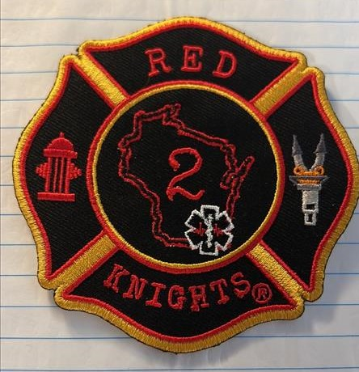
WI2 chapter patch. 4inch patch. Pay Pal is accepted. Shipping is included to the continental U.S. (add $2.50 shipping for all international orders). E-mail for more information

Item | Description | Color | Quantity | Cost ea. | Total
1 | Chapter patch WI2 | Multi |  | 15.00
2 | Item
3 | Item
4 | Item
Sub Total
Shipping and handling fees (if any)
Total

Please make check/money order out to (Wisconsin Chapter 2)
Please allow 6-8 weeks for delivery of items not in stock
All Prices US currency / Prices subject to change without notice
All items MUST be prepaid

